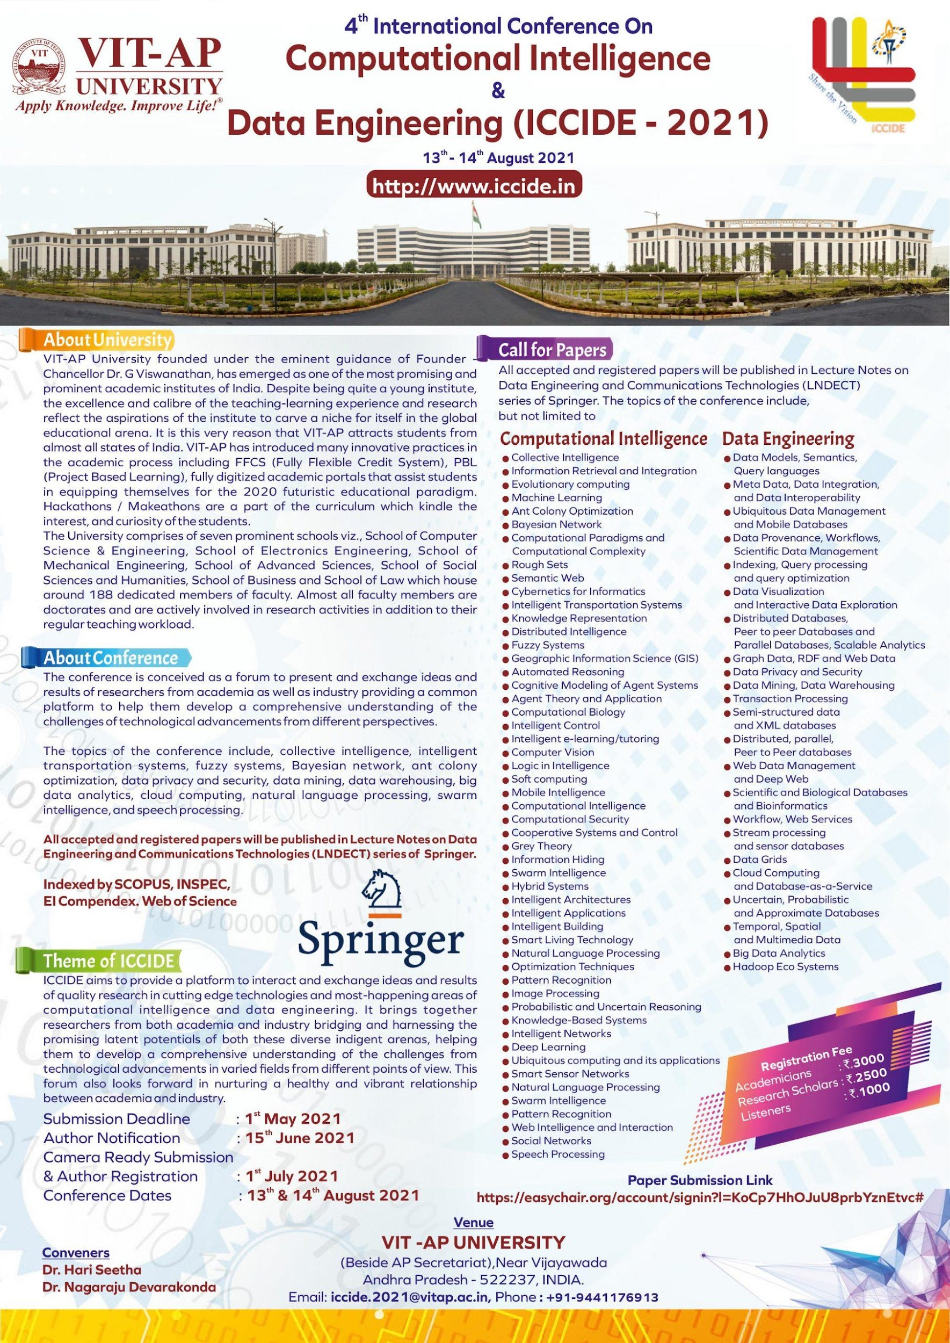

**Name of the Examination: WINTER 2022-2023 – CAT-1**

**Course Code: CSE2005 Course Title: Object Oriented Programming**

**Set number: 1 Date of Exam:**

**Duration: 90 Total Marks: 50**

**Instructions**

**Answer all the questions**

**Q1.** Create an abstract class **Seasonal_Ticket** that contains an abstract method *calculate_concession* that returns the concession for the given number of tickets. The method contains two parameters such as *total_tickets* and *ticket_price.*

Define a subclass **Group_Concession** from **Seasonal_Ticket**. It contains a constructor with two parameters such as *min_no_tickets* and *concession_percent*. It defines the method *calculate_concession* so that if the total_tickets is more than min_no_tickets, the concession is *concession_percent* percent.

Derive a class **Child_Ticket_Concession** from **Seasonal_Ticket**. The class contains a constructor with a parameter *n* denotes age of children. In addition, the class defines the method *calculate_concession* so that if the age is less than 10, concession is 50% in ticket price. Otherwise, concession 40% in ticket price.

Define a driver class **Trip**. Get the input from the user. Calculate the total_ticket_amount to be paid for the trip. Display the output. Write sample input and output.

**Q2.** Develop a java program to discount for mobilephone shopping by defining class **Shopping**. Shopping class contains the constructor such as mobile_brand_code, mobile_brand_name, price, quantity. The define a method **Payment** computes **total_amount** to be paid by the customer after discount. Also calculate the discount using the following criteria:

10% discount if total_amount >20000

5% brokerage if total_amount <=20000 and total_amount >10000

Otherwise, discount NOT Applicable for this customer.

Feed the user input using Scanner class.

Write the sample input and output.

**Q3.** Develop a java program to print a receipt for the tuition fee payment. Define a class TuitionFee with the properties such as student_roll, name, branch, semester, fee_per_year, first_installment, balance_to_be_paid. Assign the values using **set_details()** method. Print the receipt using **get_details()** method. The Fee_Payment() method computes the balance amount to be paid by the student. Read the user input using Scanner class and Write the sample input and output.

**Q4.** Create a package using java program. Anoop wants to get a Taxi for traveling to 250 Kms. He wants to get taxi with less rent. Define a package **Trave**l with a class **Taxi** to provide the price list and facilities such as Passenger_count, AC, Non-AC, Taxi_Type, rent_per_hour, min_hours. Assign the values using constructor to these variables. Taxi class contains a method ***calculate_rent*** that calculates the total_rent.

Import this package to another class with attributes like final_rent_amount, Penalty. Penalty will be levied as per following criteria.

1. If min_hour > 10, penalty is 10% additional to the rent_per_hour.
2. If min_hour <=10 and min_hour > 5 , penalty is 15% additional to the rent_per_hour
3. If min_hour <=5 and min_hour > 0, penalty is 20% additional to the rent_per_hour
4. Otherwise, No Penalty

Feed the input from a user.

Write the sample input and output.

**Q5.** Develop a java program using object cloning. Define a class **Placement** with variables department_name, specialization, contact_no. The class Placement contains the constructor to assign the values for those variables. Define a class **Applicant** with variables applicant_id, applicant_name and object placement. Assign the values to these variables using Applicant constructor. Create an object obj1 for the class Applicant. Next, Copy (clone) this object obj1 into obj2. Update the department_name, specialization, contact_no features in cloned object obj2.

a. Feed the input from the user

b. Display the original object obj1 values.

c. Display the copied object obj2 values.

d. Check the original object values are either updated or not.

e. Find the cloning is shallow or deep cloning.

**QP Mapping**

|  |  |  |  |  |  |  |
| --- | --- | --- | --- | --- | --- | --- |
| **Q. No.** | **Module Number** | **CO Mapped** | **PO**  **Mapped** | **PEO**  **Mapped** | **PSO Mapped** | **Marks** |
| Q1 | 1 | **CO** 1 | 1, 2 |  |  | 10 |
| Q2 | 1 | **CO** 1 | 1,2,3 |  |  | 10 |
| Q3 | 1 | **CO** 1 | 1,2,3 |  |  | 10 |
| Q4 | 2 | **CO** 2 | 1,2,3 |  |  | 10 |
| Q5 | 2 | **CO** 2 | 1,2,3 |  |  | 10 |
|  |  |  |  |  |  |  |